EJC EXAMPLE 2
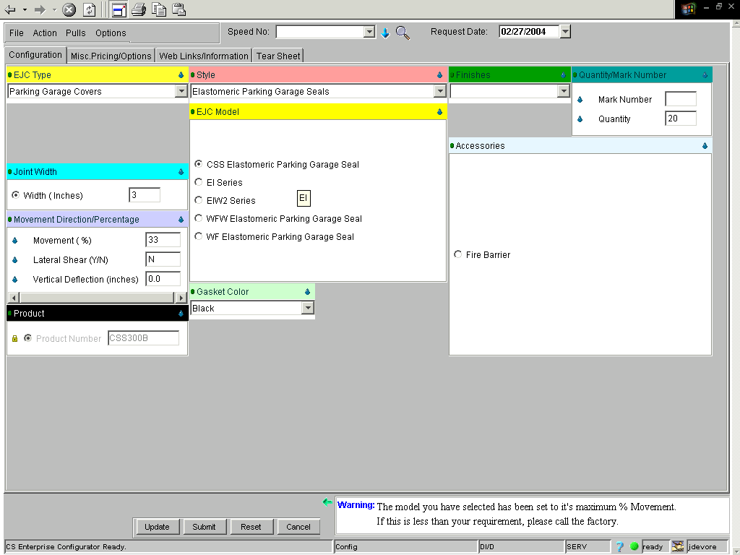
If done correctly, your price will equal $621.20.

